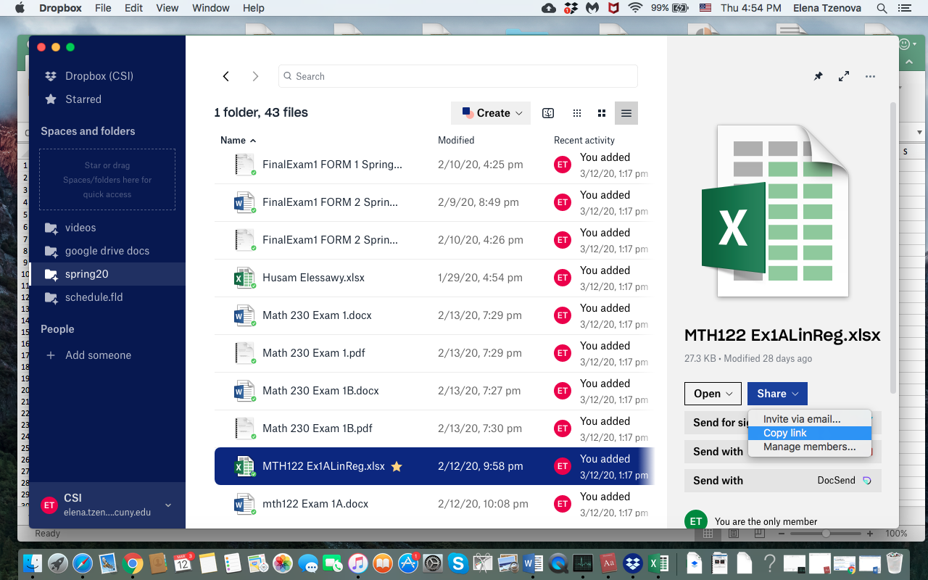

Or you could just do it with right click on the file and the select from pull-down menu “copy link”.

I found useful also the following tutorial on how to use Blackboard Collaborate on you tube https://www.youtube.com/watch?v=4Bpqla3Bxok

